Exp No: 11 STUDY OF GPIO & BIT ADDRESSING IN AT89C51
AIM:
To study GPIO control and bit-addressable SFR using Embedded C.
SOFTWARE REQUIRED:
• Keil THEORY 8051 ports are byte and bit addressable. Using sbit, individual bits of a port can be accessed directly. Ports default to logic HIGH due to internal pull-ups.
PROGRAM:
#include <reg51.h>
sbit LED1 = P1^0;
sbit LED2 = P1^1;
void delay() {
unsigned int i,j;
for(i=0;i<200;i++)
for(j=0;j<1000;j++);
}
void main() {
while(1) {
LED1 = 1;
LED2 = 0;
delay();
LED1 = 0;
LED2 = 1;
delay();
}
}

OUTPUT:
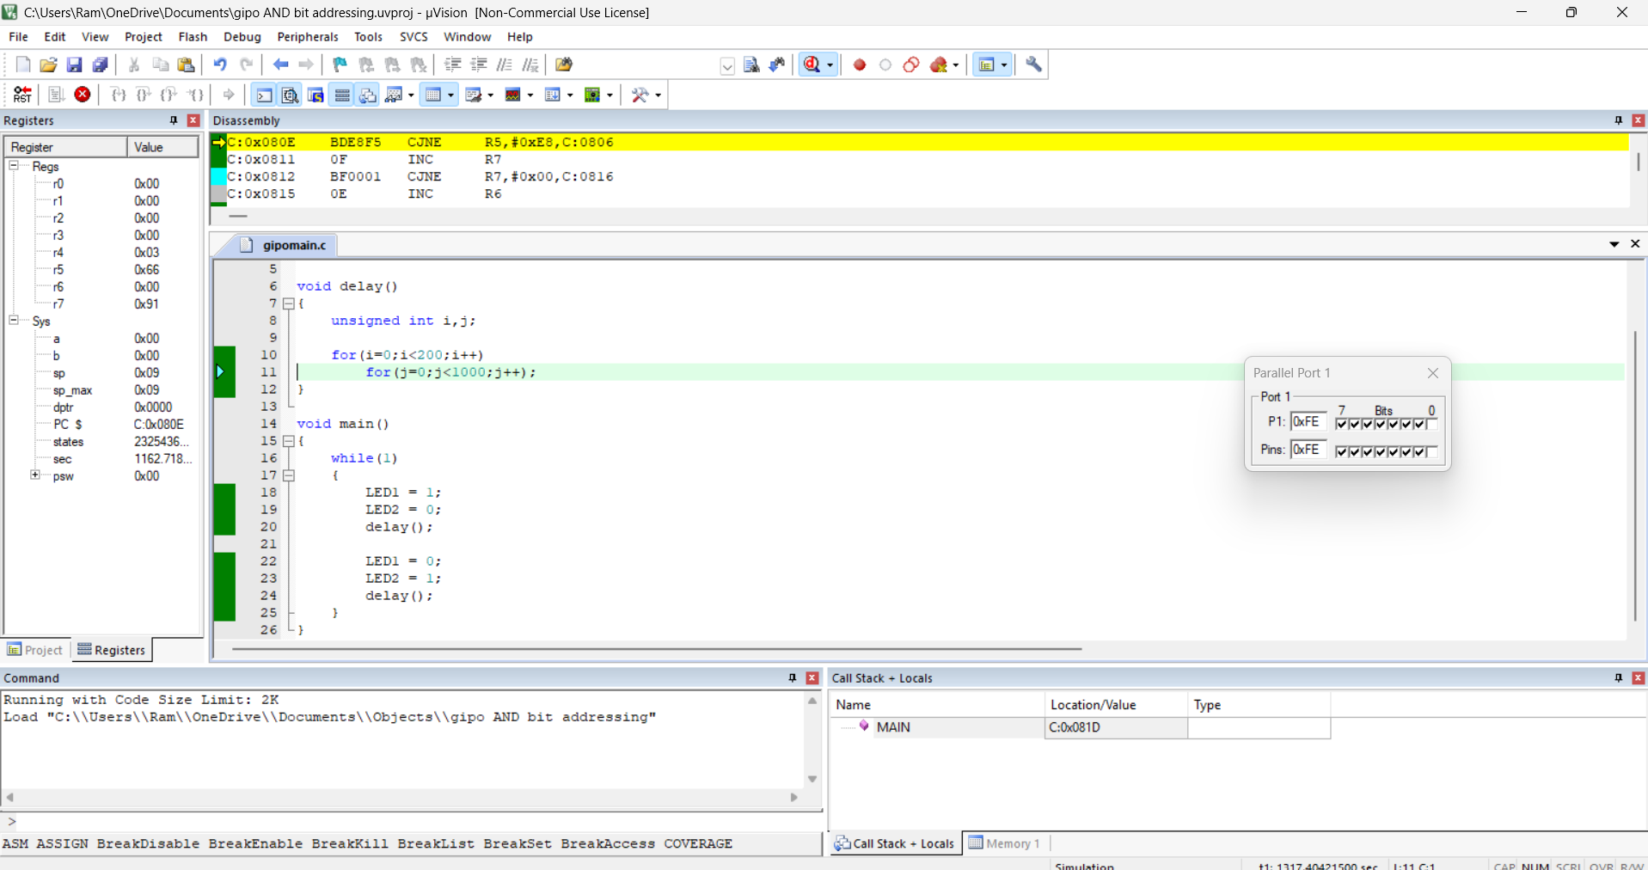

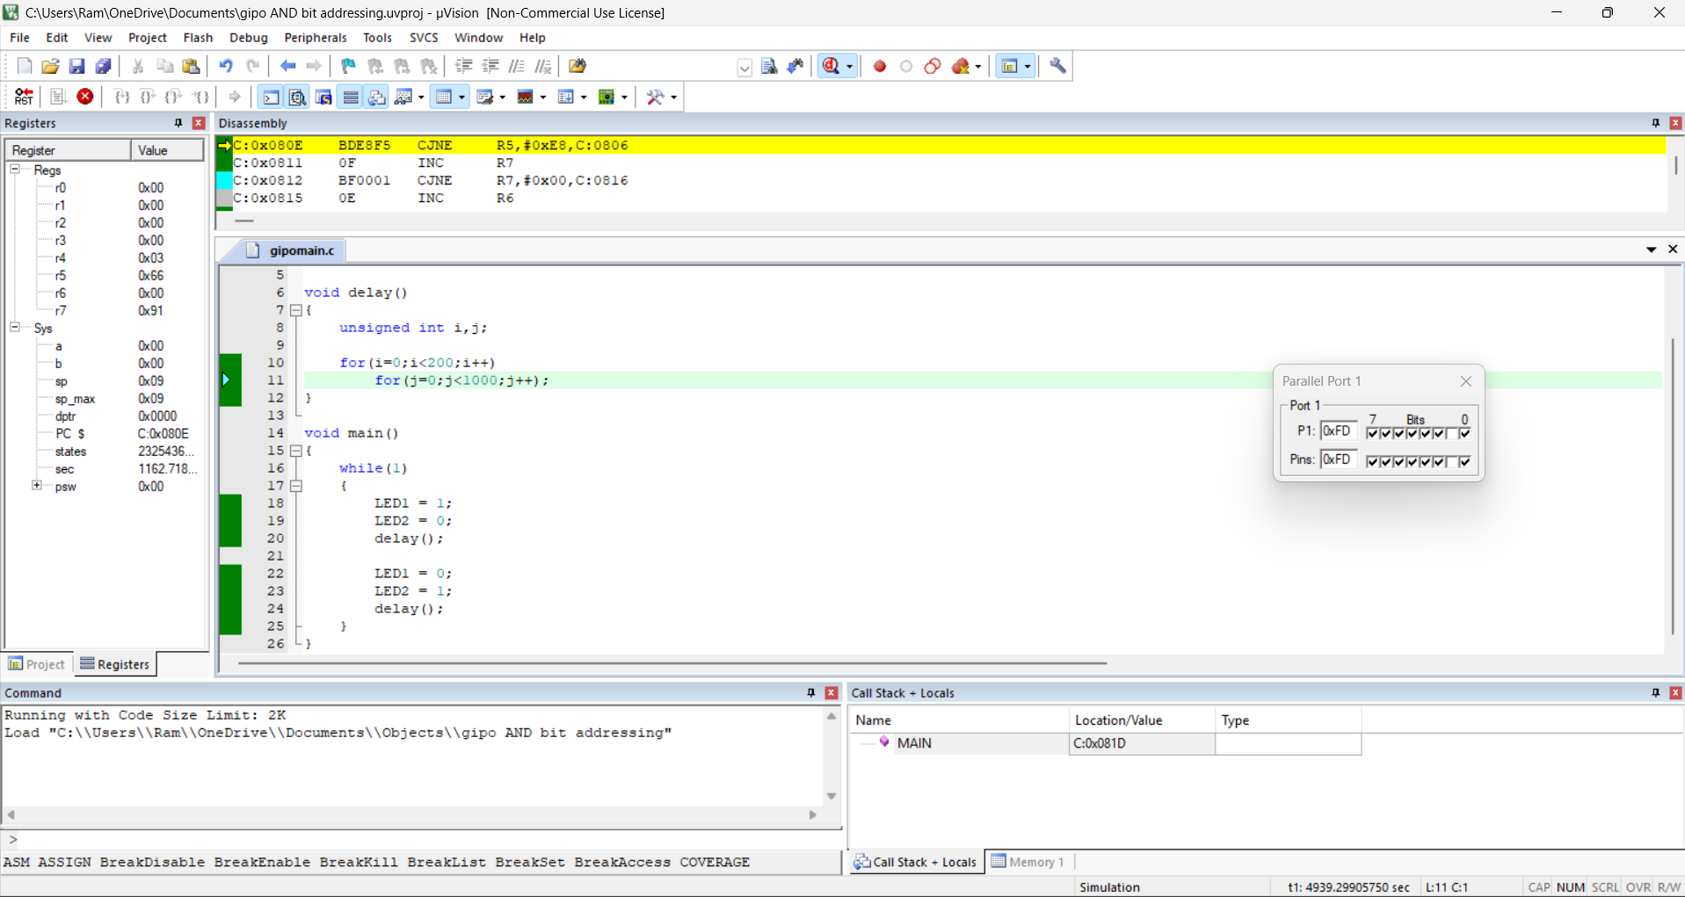

OBERVATION:
Register | Value
P1 | 0x01
P1 | 0x02

RESULT:
Register Value P1 0x01 P1 0x02 Thus GPIO and bit addressing was studied and in Port1 the pins P1.0 and P1.1 toggled alternately.

